**OUTPUT:**

In command Window, enter the particular parameter number you need to train and particular speech/sound you need to test.Below figures shows the Expected Outputs for applied emotional speech signal and pre-emphasized signal for different speech/sound samples.

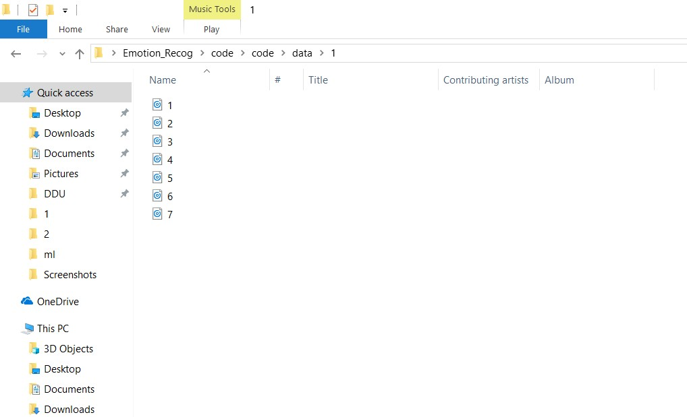

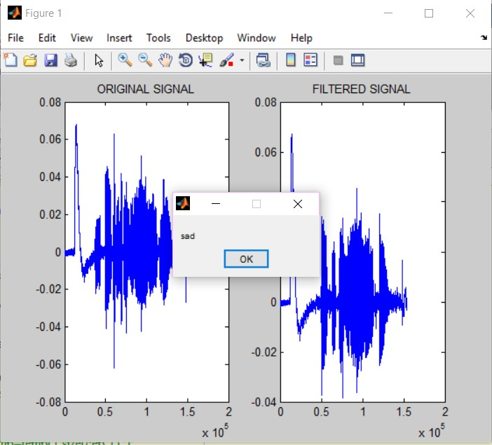

**Expected output of Sad**

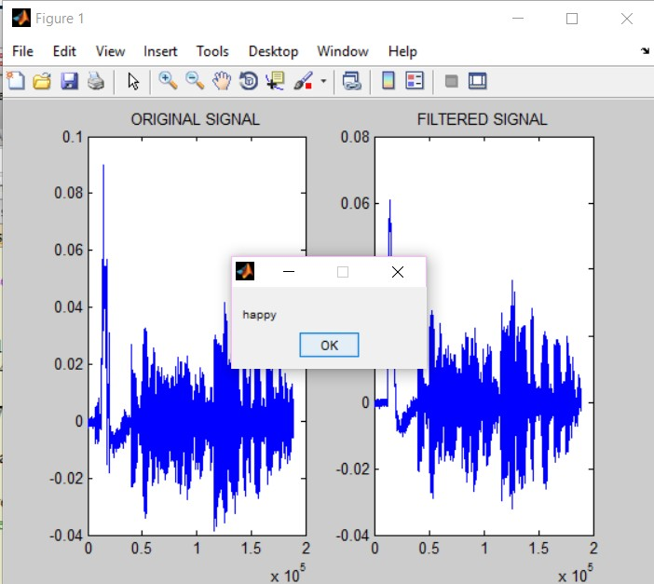 **Expected output of Happy**

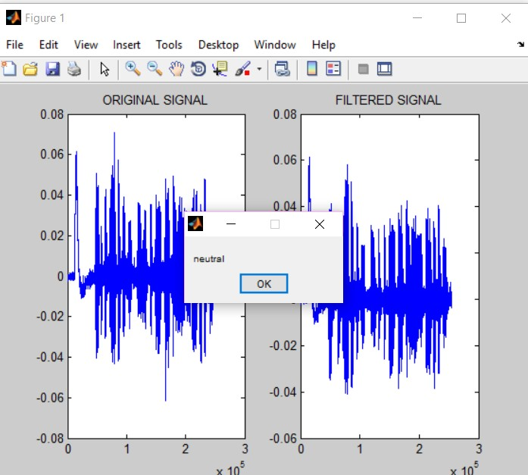

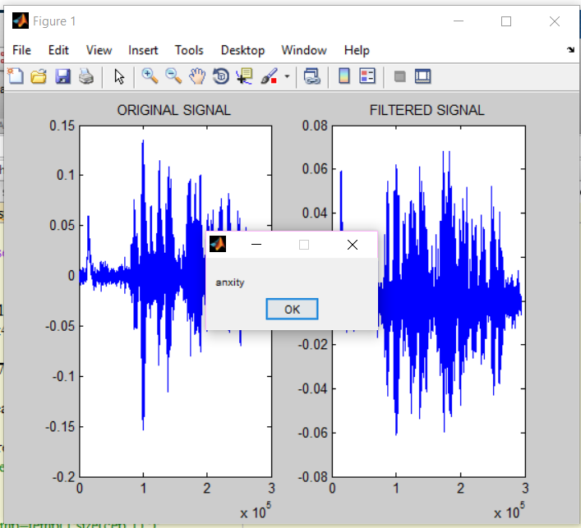**Expected Output ofNeutral**

**Expected Output of Anxiety**